**FR. CONCEICAO RODRIGUES COLLEGE OF ENGINEERING**

Fr. Agnel Ashram, Bandstand, Bandra (W), Mumbai-400050

**DEPARTMENT OF INFORMATION TECHNOLOGY**

**AUTOMATA THEORY QUESTION BANK (UT 1)**

1. Design a DFA for decimal number divisible by 4.
2. Design a DFA for binary number divisible by 3.
3. Design a DFA to accept a string ending in “aba” over ∑ = {a, b}.
4. Design a DFA to accept a string with even number of 0’s and odd number of 1’s over ∑ = {0,1}.
5. Design a DFA to accept all the strings containing “abb” as the substring over ∑ = {a, b}.
6. Minimize the following DFA:

|  |  |  |
| --- | --- | --- |
| ∂ | 0 | 1 |
| 🡪q0 | q3 | q1 |
| *q1 | q2 | q5 |
| *q2 | q2 | q5 |
| q3 | q0 | q4 |
| *q4 | q2 | q5 |
| q5 | q5 | q5 |

1. Minimize the following DFA:

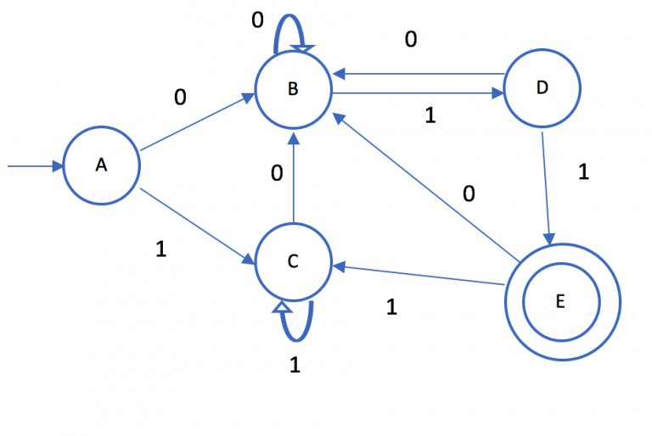

1. Minimize the following DFA:

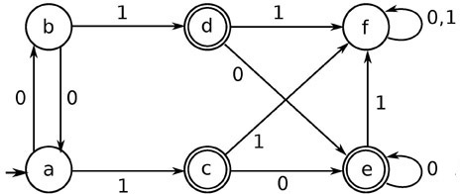

1. Design Moore and Mealy Machine to find 2’s complement of a binary number.
2. Design Moore and Mealy Machine for a binary number input sequence such that if it has a substring 010, the machine outputs A; if input has substring 101, it outputs B; otherwise it outputs C.
3. Design Moore and Mealy Machine to convert each occurrence of 100 to 101.
4. What is a Mealy Machine? Design a Mealy Machine to determine the residue mod5 of a binary number.
5. Draw €-NFA for 1*0(0+11)*
6. Draw €-NFA for (1 + 10 + 110)*0
7. Draw €-NFA for (11 + 110)* (10)*